Task 2 MULEARN X OWASP

Date : 19/07/2025

Author: Sunny Abraham Mathew

Step 1 :

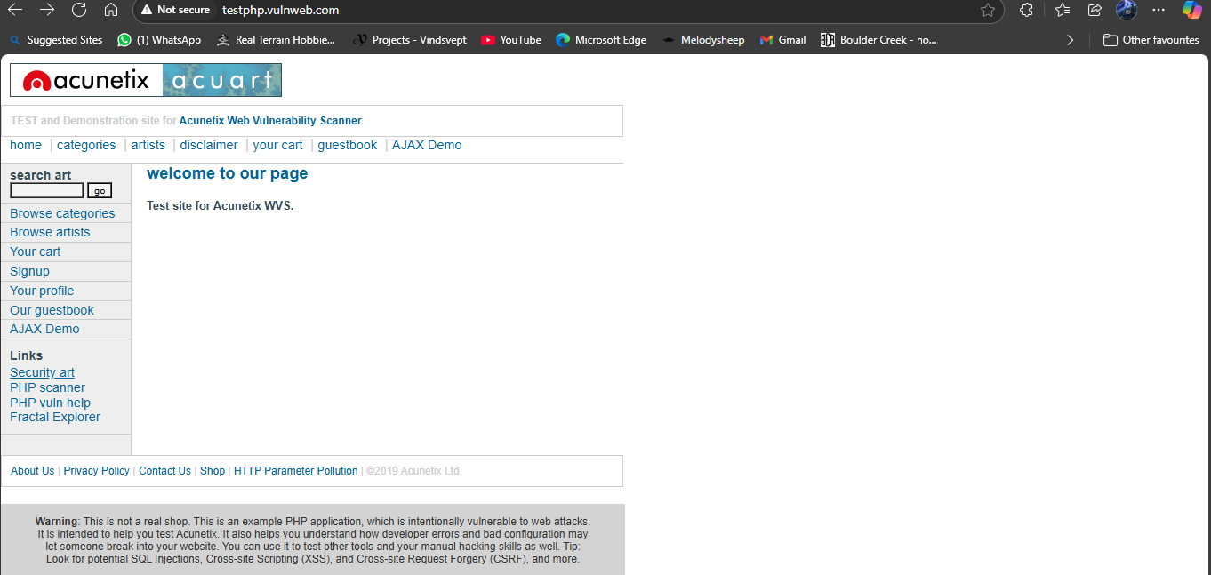  
I Took <http://testphp.vulnweb.com> which was made vulnerable for testing.

Step 2:

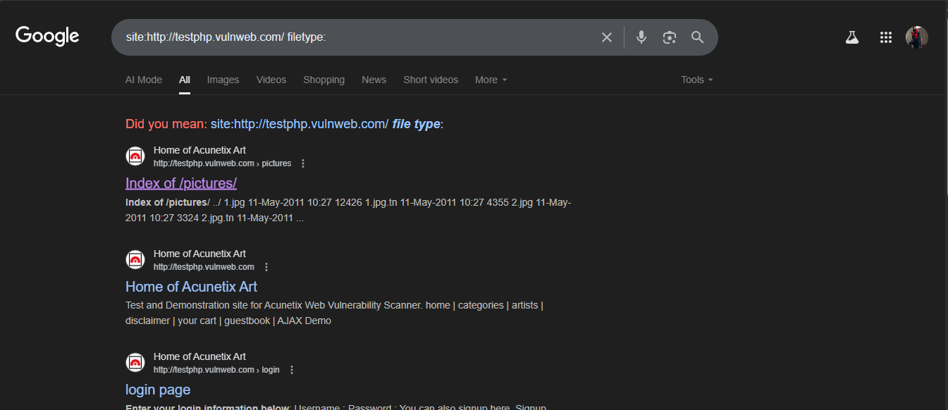

I found hidden pages using dorking.

Step3: 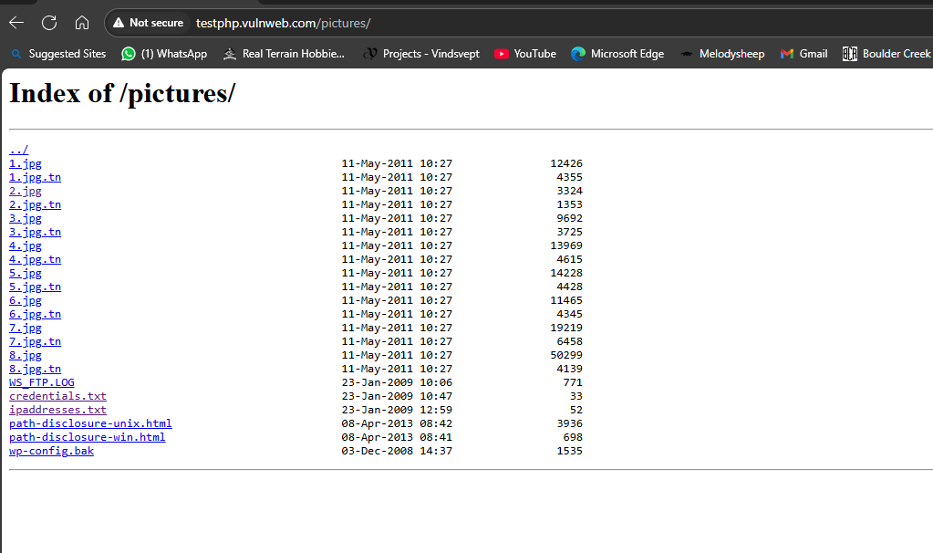

Founded hidden documents like credentials.txt and ipaddresses.txt